%converting volume percentage of ethanol to mole fraction:

liters_gin=10;

percent_ethanol_gin=0.4;

percent_water_gin=1-percent_ethanol_gin;

%using density (in g/L) and molar mass (in g/mol) to calculate moles:

mol_ethanol=liters_gin*percent_ethanol_gin*789/46.07;

mol_water=liters_gin*percent_water_gin*1000/18.016;

mol_total=mol_ethanol+mol_water;

%dividing the calculated moles by the mol total to get mol fraction:

ethanol_mol_fraction=mol_ethanol/mol_total;

water_mol_fraction=mol_water/mol_total;

SAMPLE OUTPUT w/ 10L input feed:

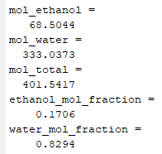

%calculating mole fraction in liquid and vapor phase, looping for the 5

%runs

%setting initial z (mol composition of feed) values:

z1=ethanol_mol_fraction; z2=water_mol_fraction;

for i=1:5

%using antoine equation and vapor pressure values from Poling, Prausnitz, and O’Connell (2001),

%antoine eqn: ln Psat[kPa] = A - B/(C+T[degC])

A1=16.8958; B1=3795.17; C1=230.918; %for ethanol (1)

A2=16.3872; B2=3885.70; C2=230.170; %for water (2)

pressure=101.325; %pressure at which the VLE apparatus operates

%finding the bubble and dew temp to determine the appropriate temp

%range for the runs:

bubble_temp=fzero(@(bubble_temp) pressure-z1*exp(A1-B1/(bubble_temp+C1))-z2*exp(A2-B2/(bubble_temp+C2)), 75);

dew_temp=fzero(@(dew_temp) 1/pressure-z1/exp(A1-B1/(dew_temp+C1))-z2/exp(A2-B2/(dew_temp+C2)), 75);

%getting the temp input for each run

temp=input(['Input temperature of run ' num2str(i) ' (in Celsius, between ' num2str(bubble_temp) ' and ' num2str(dew_temp) '): ']);

%using Raoult's law, $y_{i}P=x_{i}P_{i}^{sat}$ and Rachford-Rice eqn, $\sum{\frac{z_{i}(K_{i}-1)}{1+\frac{V}{F}(K_{i}-1)}=0}$

sat_pressure_ethanol=exp(A1-(B1/(temp+C1)));

sat_pressure_water=exp(A2-(B2/(temp+C2)));

%solving Rachford-Rice equation numerically to find a=V/F:

K_ethanol=sat_pressure_ethanol/pressure;

K_water=sat_pressure_water/pressure;

k_ethanol=1/(K_ethanol-1); k_water=1/(K_water-1);

a=fzero(@(a) z1/(k_ethanol+a) + z2/(k_water+a), 1);

%solving the molar composition of the liquid (x1 and x2) and vapor (y1 and y2) phases from a

x1=z1/(1+a*(K_ethanol-1)); x2=z2/(1+a*(K_water-1));

y1=K_ethanol*x1; y2=K_water*x2;

SAMPLE OUTPUT w/ 10L input feed:

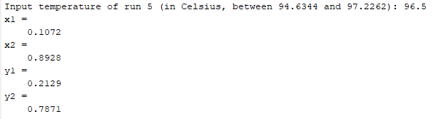

%performing mass balance on the system

%where eqn1 is the overall mass balance, L+V=total moles

%and eqn2 is the ethanol mass balance, x1L+y1V=z1*total moles

eqn1=[1, 1; x1, y1]; eqn2=[mol_total; z1*mol_total];

sol=linsolve(eqn1,eqn2);

mol_total=sol(2); %new total moles is the vapor output

%converting moles and mol fraction to volume and volume percent using density (in g/L) and molar mass (in g/mol)

volume_ethanol=mol_total*y1*46.07/789;

volume_water=mol_total*y2*18.016/1000;

volume_total=volume_ethanol+volume_water;

fprintf('Total volume (liters): %.3f\n%%v/v ethanol: %.2f%%\n%%v/v water: %.2f%%\n', volume_total, volume_ethanol/volume_total*100, volume_water/volume_total*100);

z1=y1; z2=y2; %new feed composition is the resulting liquid composition

end

FINAL OUTPUT W/ THE CHOSEN TEMPERATURES

